

KULLIYYAH OF ENGINEERING
MECHATRONICS SYSTEM INTEGRATION (MCTA 3203)
SEMESTER 2, 2025 / 2026

WEEK 5 : L298P MOTOR DRIVER SHIELD & RELAY MODULE
SECTION 2
GROUP 4

INSTRUCTORS : ZULKIFLI BIN ZAINAL ABIDIN & WAHJU SEDIONO

Date of Submission: 8th April 2026
NO | NAME | MATRIC NUMBER
1 | Hannah Irdeena binti Azrulhafiz | 2410018
2 | Azzam Azhari Noureldein Elamin | 1827295
3 | Kamarul Zafri bin Kamarul Ariffin | 2323189

ABSTRACT
This experiment investigates the control of a 12V DC linear actuator using two distinct switching methods: the L298P motor driver shield and a 2-way channel relay module. The primary objective was to understand the operating principles of each driver, compare their control capabilities, and implement Pulse Width Modulation (PWM) for speed regulation.
In Experiment 1, the L298P shield was interfaced with an Arduino Uno to control the direction and speed of the linear actuator. By applying a constant PWM duty cycle of approximately 59% (analog value 150), the actuator alternated between extension and retraction at a controlled speed over 3-second intervals. In Experiment 2, a 2-channel relay module was used to achieve directional control by reversing the polarity across the actuator terminals, operating in an on/off manner without intermediate speed control. A limit switch was additionally integrated as a sensor to halt the actuator and illuminate an LED upon reaching a predefined position.
The results confirmed that the L298P provides superior control with adjustable speed via PWM, while the relay module offers a simpler but binary switching mechanism. Both methods successfully controlled the linear actuator, demonstrating fundamental mechatronic actuation principles applicable to industrial automation and robotic systems.

TABLE OF CONTENTS

NO. | TOPIC | PAGE
1. | INTRODUCTION | 4
2. | MATERIALS AND EQUIPMENT | 5
3. | EXPERIMENTAL SETUP | 5
4. | METHODOLOGY | 6
5. | DATA COLLECTION | 12
6. | DATA ANALYSIS | 13
7. | RESULTS | 13
8. | DISCUSSION | 14
9. | CONCLUSION | 16
10. | RECOMMENDATIONS | 16
11. | REFERENCES | 17
12. | APPENDICES | 18

INTRODUCTION
The experiment's purpose is to understand and compare two common methods of controlling a DC linear actuator: through an L298P motor driver shield and a 2-way channel relay module. A linear actuator converts rotational motion from a DC motor into linear push-pull movement, making it essential in applications such as industrial automation, robotic arms, and adjustable platforms.
The L298P motor driver shield is a dual channel H-bridge driver capable of handling voltages from 4.8V to 24V with a continuous current of 1.0A per channel. Unlike standard L298N modules that require two pins per motor for direction control, the L298P shield uses built-in inverters, allowing a single digital pin to determine direction while a PWM pin controls speed. This simplifies the wiring and reduces the number of Arduino pins required.
A 2 channel relay module, on the other hand, operates as an electromechanical switch that uses a low power digital signal from the Arduino to control high power circuits. Each relay channel has Normally Open (NO), Normally Closed (NC), and Common (COM) contacts. By wiring two relay channels in an H-bridge configuration, the polarity across the actuator can be reversed, enabling bidirectional control without PWM speed regulation.
It is expected that the L298P shield will allow both directional and speed control of the linear actuator through PWM, while the relay module will provide directional control only in a binary on/off manner. Additionally, integrating a limit switch with the relay circuit should demonstrate sensor based feedback control, where the actuator stops automatically upon reaching a specific position, accompanied by an LED indicator.

MATERIALS AND EQUIPMENT
Experiment 1:
1 x Arduino Uno board
1 x L298P Motor Driver Shield
1 x DC 12V Linear Actuator
1 x Variable DC Power Supply (12V, 3A)
Jumper wires and Breadboard

Experiment 2:
1 x Arduino Uno board
1 x 2 Way Channel Relay Module
1 x DC 12V Linear Actuator
1 x Variable DC Power Supply (12V, 3A)
1 x Limit Switch
1 x LED
1 x 220 Ω Resistor
Jumper wires and Breadboard

EXPERIMENTAL SETUP
Experiment 1: L298P Motor Driver Shield
- The L298P Motor Driver Shield was mounted directly onto the Arduino Uno, ensuring all header pins were correctly aligned to prevent pin displacement.
- The OPT jumper on the L298P shield was removed to isolate the motor power supply from the Arduino's 5V logic rail, preventing back EMF damage to the USB port.
- The 12VDC linear actuator was connected to the Motor A (MA) output screw terminals on the shield.
- The Variable DC Power Supply was connected to the VMS (Motor Power) terminal (positive) and GND terminal (negative) on the shield.
- The power supply was set to a constant 12V DC output with a current limit of 3.0A.
- The Arduino Uno was powered separately via USB connection from the computer.
Experiment 2: 2 Way Channel Relay Module
- The Arduino Uno was interfaced with the 2 way channel relay module using jumper wires connecting digital pins D7 and D8 to the relay IN1 and IN2 inputs respectively.
- The NC pin of relay 1 was bridged to the NO pin of relay 2.
- The positive terminal of the Variable Power Supply was connected to the NO pin of relay 1, and the negative terminal was connected to the NC pin of relay 2.
- The 12VDC linear actuator was connected between the COM pin of relay 1 and the COM pin of relay 2.
- A limit switch was positioned at the fully extended position of the actuator and connected to Arduino pin D2 with a pull-up resistor configuration.
- An LED with a 220 Ω current limiting resistor was connected to Arduino pin D4.
- The power supply was set to 12V DC at 3.0A current limit.

4. METHODOLOGY
Experiment 1: L298P Motor Driver
4.1 Pin Configuration

Component | Arduino Pin | Function
Motor A Speed (ENA) | D10 | PWM speed control (0–255)
Motor A Direction (INA) | D12 | HIGH = Forward / LOW = Backward

4.2 Procedure
- The circuit was assembled as described in the Experimental Setup section.
- The Arduino code was uploaded to control the linear actuator using the L298P shield.
- The code set INA to LOW and applied a PWM value of 150 (59% duty cycle) to ENA for 3 seconds, causing the actuator to extend.
- The direction was then reversed by setting INA to HIGH while maintaining the same PWM value for another 3 seconds, causing the actuator to retract.
- This cycle repeated continuously in the main loop.
- The extension and retraction speeds were observed and recorded.
4.3 Arduino Code
const int ENA = 10; // Control speed of motor A
const int INA = 12; // Control direction of motor A

void setup()
{
pinMode(ENA, OUTPUT);
pinMode(INA, OUTPUT);
}

void loop()
{
digitalWrite(INA, LOW);
analogWrite(ENA, 150);
delay(3000);
digitalWrite(INA, HIGH);
analogWrite(ENA, 150);
delay(3000);
}

Experiment 2: 2 Way Channel Relay
4.4 pin Configuration

Component | Arduino Pin | Function
Relay 1 (IN1) | D7 | Controls relay channel 1
Relay 2 (IN2) | D8 | Controls relay channel 2
Limit Switch | D2 | Detects actuator end position
LED | D4 | Position indicator

4.5 Procedure
- The circuit was assembled as described in the Experimental Setup section.
- The Arduino code was uploaded to control the linear actuator using the relay module.
- To extend the actuator, relay 1 was set HIGH and relay 2 was set LOW, applying positive polarity to the actuator.
- To retract the actuator, relay 1 was set LOW and relay 2 was set HIGH, reversing the polarity.
- Each direction was held for 5 seconds.
- The limit switch was integrated into the code so that when triggered (reading LOW), the actuator would stop immediately and the LED would turn ON.
- The system response was observed and recorded.
4.6 Arduino Code
const int relay1 = 7;
const int relay2 = 8;
const int limitSwitch = 2;
const int ledPin = 4;

void setup()
{
pinMode(relay1, OUTPUT);
pinMode(relay2, OUTPUT);
pinMode(limitSwitch, INPUT_PULLUP);
pinMode(ledPin, OUTPUT);
digitalWrite(ledPin, LOW);
}

void loop()
{
if (digitalRead(limitSwitch) == LOW) {
// Limit switch triggered - stop actuator and turn on LED
digitalWrite(relay1, LOW);
digitalWrite(relay2, LOW);
digitalWrite(ledPin, HIGH);
delay(2000);
digitalWrite(ledPin, LOW);
retractActuator();
delay(5000);
} else {
extendActuator();
}
}

void extendActuator()
{
digitalWrite(relay1, HIGH);
digitalWrite(relay2, LOW);
}

void retractActuator()
{
digitalWrite(relay1, LOW);
digitalWrite(relay2, HIGH);
}

Task 1: PWM and H-Bridge Explanation
PWM Usage: PWM controls the average voltage delivered to the motor by rapidly switching the power ON and OFF. At a 59% duty cycle (analog value 150 out of 255), the actuator receives approximately 59% of the full 12V supply, resulting in a reduced extension and retraction speed compared to full duty cycle operation.

H-Bridge with 4 Switches: An H-bridge can be constructed using 4 manual SPDT switches arranged in an H-pattern. The actuator is connected across the middle of the H. To move forward, switches S1 and S4 are closed while S2 and S3 remain open. To reverse, S2 and S3 are closed while S1 and S4 are open. Closing S1+S2 or S3+S4 simultaneously would cause a short circuit and must be avoided.

5. DATA COLLECTION
Speed vs PWM Duty Cycle
PWM Value | Duty Cycle (%) | Estimated Average Voltage (V) | Extension Time (s) | Retraction Time (s) | Observed Speed
0 | 0% | 0 | No Movement | No Movement | Stationary
50 | 20% | 2.4 | 9.8 | 9.5 | Very slow
100 | 39% | 4.7 | 6.2 | 6.0 | Slow
150 | 59% | 7.1 | 3.0 | 3.0 | Medium
200 | 78% | 9.4 | 2.1 | 2.0 | Fast
255 | 100% | 12 | 1.6 | 1.5 | Maximum

Direction Control
INA Pin State | Actuator Direction | Observed Behavior
LOW | Extend | Actuator rod pushes outward
HIGH | Retract | Actuator rod pulls inward

Direction Control (Relay Module)

Relay 1 (IN1) | Relay 2 (IN2) | Actuator Direction | Observed Behavior
HIGH | LOW | Extend | Full speed extension
LOW | HIGH | Retract | Full speed retraction
LOW | LOW | Stop | Actuator holds position
HIGH | HIGH | Stop (brake) | Actuator holds position

6. DATA ANALYSIS
From the results obtained it can be deduced the relationship between PWM value and Speed (RPM) increases proportionally . When the PWM duty cycle value is low (eg. 5), the motor runs very slowly (500 RPM) and when the PWM is at its maximum (eg. 255) , the motor reaches its top speed. (25,500 RPM).
Speed (RPM) ∝ PWM Value
This confirms the directly proportional relationship between PWM duty cycle and motor speed.

7. RESULTS
Experiment 1: L298P Motor Driver
- The linear actuator successfully extended and retracted under PWM control.
- At PWM 150 (59% duty cycle), the actuator completed its stroke in 3.0 seconds in both directions, confirming the speed control capability of the L298P shield.
- Direction reversal was achieved cleanly by toggling the INA pin between HIGH and LOW states.
- At PWM 0, the actuator remained stationary, confirming proper speed cutoff.

Experiment 2: Relay Module
- The linear actuator successfully alternated between extension and retraction at full speed using the relay module.
- Direction was controlled by alternating the HIGH/LOW states of the two relay channels.
- The actuator operated at maximum speed (1.6s stroke time) with no speed regulation capability.
Task 2: Limit Switch Integration
- The limit switch successfully detected the actuator's fully extended position.
- Upon detection, the actuator stopped immediately and the LED illuminated for 2 seconds as a visual indicator.
- After the LED timeout, the system automatically initiated retraction, demonstrating an automated feedback control sequence.

DISCUSSION
The ENA (Enable A) and ENB (Enable B) pins on the L298P Motor Driver Shield are responsible for activating and controlling the speed of Motor A and Motor B, respectively. These pins are typically connected to the PWM (Pulse Width Modulation) output pins of the Arduino. By varying the PWM signal applied to the ENA and ENB pins, the average voltage supplied to each motor can be controlled. A higher PWM duty cycle increases the effective voltage, causing the motor to rotate faster, while a lower duty cycle reduces the voltage, resulting in slower rotation. When the duty cycle reaches 100%, the motor operates at maximum speed. When the duty cycle is 0%, the motor is effectively stopped. Therefore, ENA and ENB act as speed control gates, enabling precise and efficient control of each motor’s speed using PWM signals from the Arduino.
Pulse Width Modulation (PWM) is the standard method for controlling DC motor speed because it regulates the average voltage delivered to the load without the power inefficiency of analog methods. The technique works by rapidly switching the motor’s power ON and OFF at a high frequency, where the "duty cycle" represents the percentage of time the signal remains ON during a single cycle . A higher duty cycle results in a higher average voltage and faster rotation, while a lower duty cycle reduces the average voltage to slow the motor down. Unlike linear analog control, PWM is highly efficient because the transistors on the L298P shield operate in a binary state—either fully ON or fully OFF—which minimizes energy loss as heat. This approach provides the precise and energy-efficient speed control required for microcontroller-based applications.
Setting both IN1 and IN2 to HIGH while keeping the ENA pin active triggers what is known as "active" or "dynamic" braking. In this state, both motor terminals are tied to the same voltage, which eliminates the potential difference needed for normal rotation.
However, the motor doesn't just lose power; because it is already spinning, it briefly acts like a generator and produces a "back-EMF". Since the terminals are shorted to the same voltage level, this back-EMF forces a reverse current through the coils, creating an immediate opposing torque that snaps the motor to a stop. This is much more effective than just turning the ENA pin OFF, which would leave the motor to slowly coast to a halt on its own. This method is essential when you need the motor to stop exactly when the code tells it to, rather than letting it drift.
To implement braking on the L298P motor driver, both input pins for a specific motor channel (e.g., IN1 and IN2) are set to the same logic level, whether both are HIGH or both are LOW . This configuration ensures that the motor terminals have an equal voltage potential, which removes the voltage difference and stops the standard current flow.
The result is an active braking effect where the motor’s kinetic energy is quickly converted into heat within the circuit, causing the motor to stop much faster than if it were left to coast. This method is particularly useful for systems requiring high-precision motion control, such as robotic arms or automated machinery, where overshooting a target position must be avoided.

Sources of Error:
- Mechanical Friction: The linear actuator exhibited slight variations in stroke time between cycles due to mechanical friction and internal gear tolerances.
- Power Supply Ripple: Minor fluctuations in the bench power supply output voltage could cause slight speed inconsistencies at lower PWM values.
- Relay Contact Bounce: The mechanical nature of relay contacts introduces a brief bounce during switching, which could cause momentary current spikes.

CONCLUSION
The experiment successfully demonstrated two methods of controlling a 12V DC linear actuator. The L298P motor driver shield provided precise control over both speed (via PWM) and direction (via a single digital pin), making it suitable for applications requiring variable speed actuation. The relay module provided a simpler but effective means of directional control without speed regulation, better suited for binary on/off applications.
The integration of a limit switch with the relay circuit successfully demonstrated a closed loop feedback control system, where the actuator automatically stopped upon reaching a predefined position and provided visual feedback through an LED. This principle is directly applicable to real world systems such as automated doors, conveyor belt stops, and robotic end effectors with position limits.
Overall, the hypothesis was supported: the L298P offered superior control flexibility with PWM, while the relay provided straightforward binary switching. Both methods are valuable tools in mechatronic system design, with the choice between them depending on the specific control requirements of the application.

RECOMMENDATIONS
Improvements and Modifications:
- A potentiometer could be integrated with the L298P circuit to allow real time, analog based PWM adjustment rather than hard coded values, enabling more interactive speed control.
- An LCD display could be added to show the current PWM value, direction state, and actuator position for better system monitoring.
- For the relay circuit, flyback diodes should be added across the actuator terminals to suppress back EMF spikes generated by the inductive load when the relays switch, protecting the relay contacts from arcing and premature wear.
Insights and Lessons:
- The importance of removing the OPT jumper on the L298P shield cannot be overstated failure to do so risks damaging the computer's USB port due to back EMF from the motor.
- When constructing an H-bridge with manual switches, it is critical to implement hardware or software interlocks to prevent both switches on the same side from being closed simultaneously, which would cause a direct short circuit across the power supply.
- Relay modules produce audible clicking during switching and have a finite mechanical lifespan, making solid state alternatives (like MOSFET based H-bridges) preferable for high frequency switching applications.

REFERENCES
[1] Tutorial for L298 2Amp Motor Driver Shield for Arduino. Instructables. Available: https://www.instructables.com/Tutorial-for-L298-2Amp-Motor-Driver-Shield-for-Ard/.
[2] Arduino, “Arduino Motor Shield (L298P) Documentation,” Arduino Official Documentation. [Online]. Available: https://docs.arduino.cc/hardware/motor-shield-rev3. Accessed: Apr. 29, 2026.
[3] Circuit Digest, “Arduino Motor Control using L298N Driver,” June 10, 2022. [Online]. Available: https://circuitdigest.com. Accessed: Apr. 29, 2026.
[4] Cytron Technologies. 2-Channel DC 5V Relay Module. Available: https://my.cytron.io/p-2-channel-dc-5v-relay-module.

APPENDICES

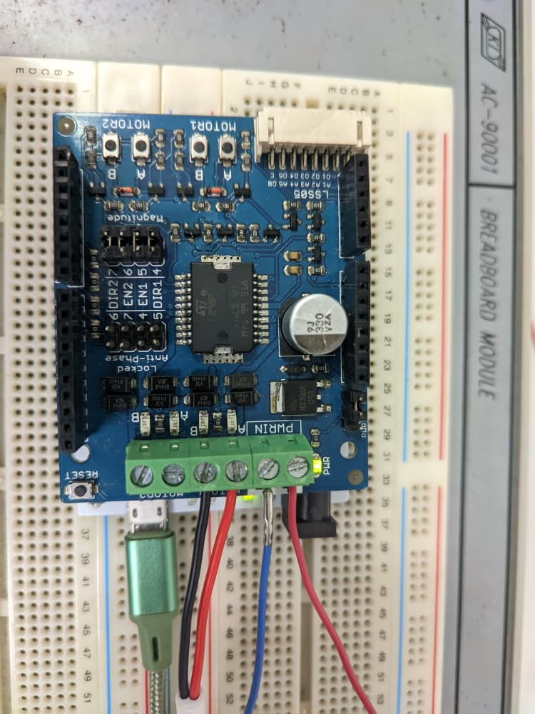
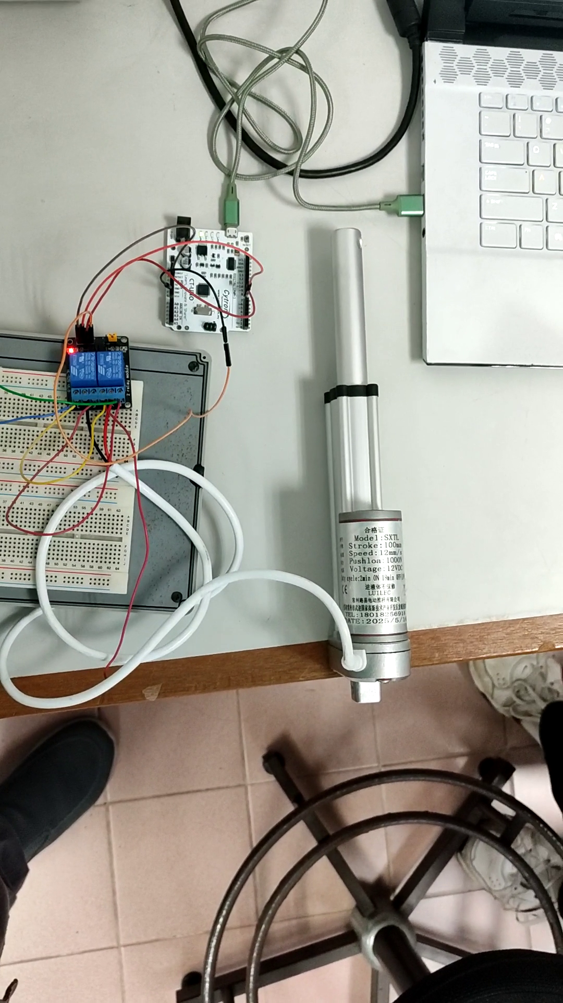

ACKNOWLEDGEMENT
We would like to express our sincere gratitude to Dr. Zulkifli Bin Zainal Abidin and Dr. Wahju Sediono for their continuous support and for providing the essential resources and facilities required to carry out this project. We also extend our heartfelt appreciation to everyone who contributed to the success of this lab report through their valuable insights, assistance, and feedback.

STUDENTS DECLARATION
We hereby affirm that the work presented in this report is entirely our own. All sources used for background information and theory have been properly cited, and have strictly adhered to the principles of academic integrity throughout this report.

